STAFF ANALYSIS
STAFF PERSON: Ben Loppacker, Planner I
BOARD OF SUPERVISORS: March 4, 2026
PROJECT: SE-2025-00039 Turkey Knob Solar
PARCEL IDs: 10500-00-00-12400

PROPOSAL
A by-right 21 acre solar facility is proposed on the subject property. By-right ground-mounted solar energy facilities in the Rural Areas (RA) zoning district are limited to a maximum of 21 acres of fenced area on any parcel in existence at the time of adoption of this ordinance. The total project area associated with the facility is 53.5 acres, which would include access and perimeter buffers, with the 21 acre or less fenced panel area within the 53.5 acres.

The applicant seeks a special exception from two provisions of County Code § 18-5.1.66 for the facility:
- To allow an energy facility to disturb more than ten acres in a forest block as identified in the Comprehensive Plan/Biodiversity Action Plan.
- To allow an energy facility to disturb more than ten acres of prime farmland as determined by the United States Department of Agriculture’s Natural Resources Conservation Service.

Staff cannot waive or modify County Code § 18-5.1.66(A)(16) or § 18-5.1.66(A)(17) administratively. Any waiver or modification is subject to Board of Supervisors’ approval.

CHARACTER OF THE AREA
The subject property is approximately 200.5 acres and is currently undeveloped, but has been timbered previously in 2021. An existing powerline runs through the property within an approximately 140 foot right of way. Buck Island Creek is located to the north of the parcel. The property fronts on Buck Island Road along its eastern property line, which would provide access to the solar facility. The property is zoned Rural Areas and located in the Rural Area of the Comprehensive Plan. Surrounding properties to the north, south, east and west are all zoned Rural Areas, some with rural residential uses. The site is approximately a half mile from the existing Rivanna Solar facility on Thomas Jefferson Parkway and is approximately a quarter mile from the Buck Island Solar project, whose site development plan is under review.

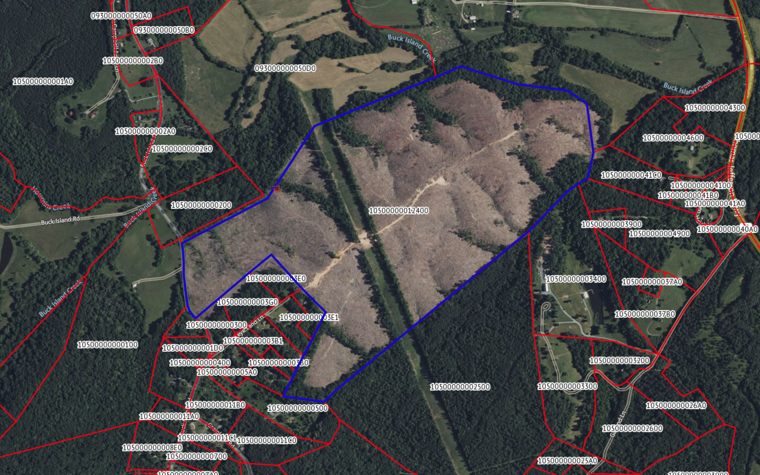
Figure 1: 2025 Aerial Imagery of the Turkey Knob Solar Site

ANALYSIS OF SPECIAL EXCEPTION REQUEST
Special exceptions are subject to County Code § 18-33.5, under which the Board may either approve or deny an application, defer action to allow for changes prior to final action, or refer the application to the Planning Commission.

County Code §18-5.1 provides that the Board of Supervisors may modify or waive any requirement of Section 5 upon a finding that:
1. Such requirement would not forward the purposes of this chapter or otherwise serve the public health, safety, or welfare; or
2. that a modified regulation would satisfy the purposes of this chapter to at least an equivalent degree as the specified requirement

Staff offers the following analysis of the proposed modification against these criteria (below). The special exception process allows for the County to consider site-specific analysis, which the applicant has provided. Staff does not have concerns with the applicant’s methodology or findings.

County Code § 5.1.66(A)(16): “By-right projects must not disturb more than 10 acres in the aggregate of habitat cores, forest blocks, or corridors connecting habitat areas, as these features are identified in the Comprehensive Plan/Biodiversity Action Plan.

The Board of Supervisors may permit disturbance of more than ten acres of forest blocks by special exception.

When considering impacts to habitat areas, on both special exception and special use permit applications, the Board of Supervisors should consider:
- the Comprehensive Plan/Biodiversity Action Plan,
- the Virginia Department of Conservation and Recreation Natural Heritage Data Explorer, or
- other County-designated resources for this purpose, as well as determine the particular mix of species and composition of affected habitat areas.

As noted above, the applicable standard for measuring disturbed habitat cores, forest blocks, or corridors connecting habitat areas is the Comprehensive Plan/Biodiversity Action Plan. However, the area in question is not a high scoring forest block for conservation value (Figure 3), but is instead identified as a small forest block on the Forest Blocks and Tree Cover Map (Figure 4) contained in the Comprehensive Plan.
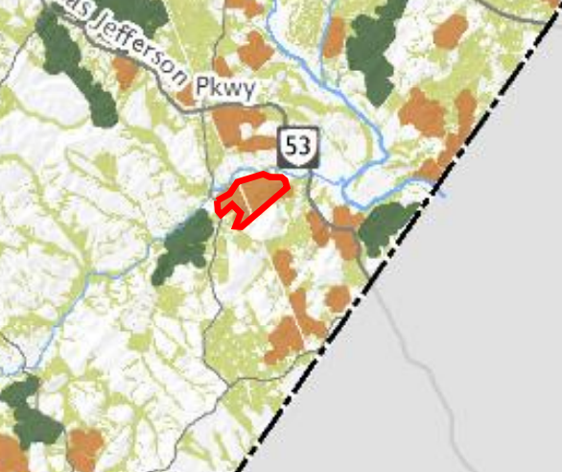
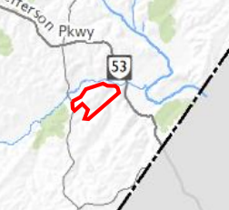
Figure 3 Ranking the Conservation Value of Forest Blocks Figure 4 Forest Blocks and Tree Cover in Albemarle

The Comprehensive Plan/Biodiversity Action Plan Forest Block and Tree Cover Map no longer reflect the actual conditions on the ground. Staff has confirmed that nearly all of the forest vegetation making up the forest block mapped in this location by the Biodiversity Action Plan was removed during by-right forestry operations (before the adoption of the Energy Facility regulations). The remaining 9.5 acres of forest vegetation are fragmented into many small, disjunct areas along streams and do not function as a significant habitat block. Therefore, the Biodiversity Action Plan designation of this site as a forest block, though legally applicable, no longer reflects actual conditions.

The site is not within a Conservation Focus Area as identified by the Biodiversity Action Plan (Figure 4)). The Virginia Natural Heritage Data Explorer shows the site as a small forest block and as a node in a wildlife corridor through this area, even with the existing utility corridor crossing the site. However, that mapping also predates the removal of forest vegetation from the majority of the site. The connectivity through that corridor has been significantly reduced by the prior removal of forest cover from this property.

The remaining acreage outside the solar facility would remain available for by-right uses such as forestry and agriculture, as it would if the solar facility were not constructed. Staff cannot predict what the eventual landcover will be on this remainder of the site. Staff recommends that the site be developed in general accord with the concept plan, which establishes limits of clearing. Areas of the parcel outside the solar facility could regain forest habitat value or be used for other agricultural uses by the owner. Stream buffers would not be impacted by the solar facility and downstream water quality would be protected by the Water Protection Ordinance.

If the parcel is developed as a solar facility, as proposed by the applicant, a detailed landscape plan must be provided to demonstrate that screening and landscaping meets the requirements of County Code § 18-5.1.66. Due to the current condition of the parcel, staff believes that the necessary findings have been met to grant the special exception despite the parcel’s forest block official designation.

County Code § 5.1.66(A)(17):-“By-right projects must not disturb either (a) more than 10 acres of prime farmland (as determined/identified by the United States Department of Agriculture's Natural Resources Conservation Service) and/or (b) areas used for an agricultural activity within the five years preceding an application, unless portions of the parcels used for the facility will continue to be used for an agricultural activity.”

The site has not been used for agricultural activity within the past five years of the application.

As noted above, the applicable standard for measuring disturbed prime farmland is the United States Department of Agriculture's Natural Resources Conservation Service (NRCS). However, in this case, though official NRCS maps continue to show this site as prime farmland, the applicant has submitted additional information to the contrary. Staff believes that the applicant has used applicable standards and sound methodology to come to these conclusions, as included in the application materials.

Specifically, the applicant included an infiltration test with the special exception request, in order to validate whether the area’s designation as prime farmland still meets the definition of prime farmland as set forth in Title 7 of the Code of Federal Regulations (CFR). (See Attachment E) Soil sampling tests were conducted in multiple locations within the areas identified by the NRCS maps.

The definition states that in order to be considered prime farmland, “the soils have a pH between 4.5 and 8.4 in all horizons within a depth of 40 inches (1 meter) or in the root zone if the root zone is less than 40 inches deep” and “have a permeability rate of at least 0.06 inch (0.15 cm) per hour in the upper 20 inches (50 cm)”.

The applicant performed four tests within the proposed area of disturbance for the solar facility, with the tests determining that only one test site had a permeability rate of at least 0.06 inches per hour in the upper 20 inches of soil. Therefore, staff concludes that despite the prime farmland designation on the official maps, there would not be a significant impact to prime soils under the CFR if the Board granted the special exception.

Based on staff review of the information and analysis provided by the applicant, and review of the current parcel conditions, staff believes that a modified regulation, allowing the disturbance of 53.5 acres of identified forest block and prime farmland on the parcel, subject to certain conditions, would satisfy the purposes of this chapter to at least an equivalent degree as the specified requirement.

RECOMMENDATION
Staff recommends that the Board adopt the attached Resolution (Attachment F) to grant a special exception from County Code § 5.1.66(A)(16) and 5.1.66(A)(17), provided that the site is developed in general accord with the concept plan (Exhibit 1, dated 11/24/25).

